E-project Report

**Acknowledgements**

Munirat Idunnuoluwa Shitta-Bey: The homepage, about us page, contact page, report, logo, and great team cooperation.

Miguel Ugochuckwu Okoh: Some contribution to the homepage, about us page, contact page, report, and good team cooperation.

Oluwatobilola Daniel Kuti: Some contribution to the homepage, about us page, contact page, report, and good team cooperation.

Oluwaseyi Emmanuel Bushura: Some contribution to the report and fair team cooperation.

Moriom Oluwatobi Ariyibi: Some contribution to the report and fair team cooperation.

**e-Project Synopsis**

The project was about making a website for people to see the amazing beaches in their area or around the world and providing transport for them to go to the beach of their choice.

**e-Project Analysis**

* We had to add About us, Contact us, Gallery, and Queries links
* We had to make a visitor count
* Display images of famous beaches in a slideshow with bootstrap below the navbar
* Show different zones for the beaches
* Make a map that displayed beaches near the user
* Add a feedback section
* Add a sitemap
* Add a gallery of different beaches
* Make a section that the user can choose with transport they want to use to get to the beach of their choice
* Allow the user to download a pdf. That contained more information of our company
* Use geolocation to show user’s current date and location

**e-Project Design**

DFD:

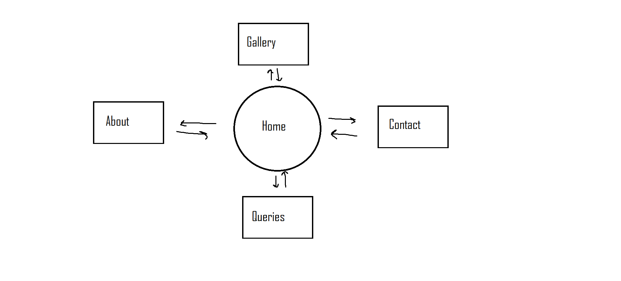

Flowchart:

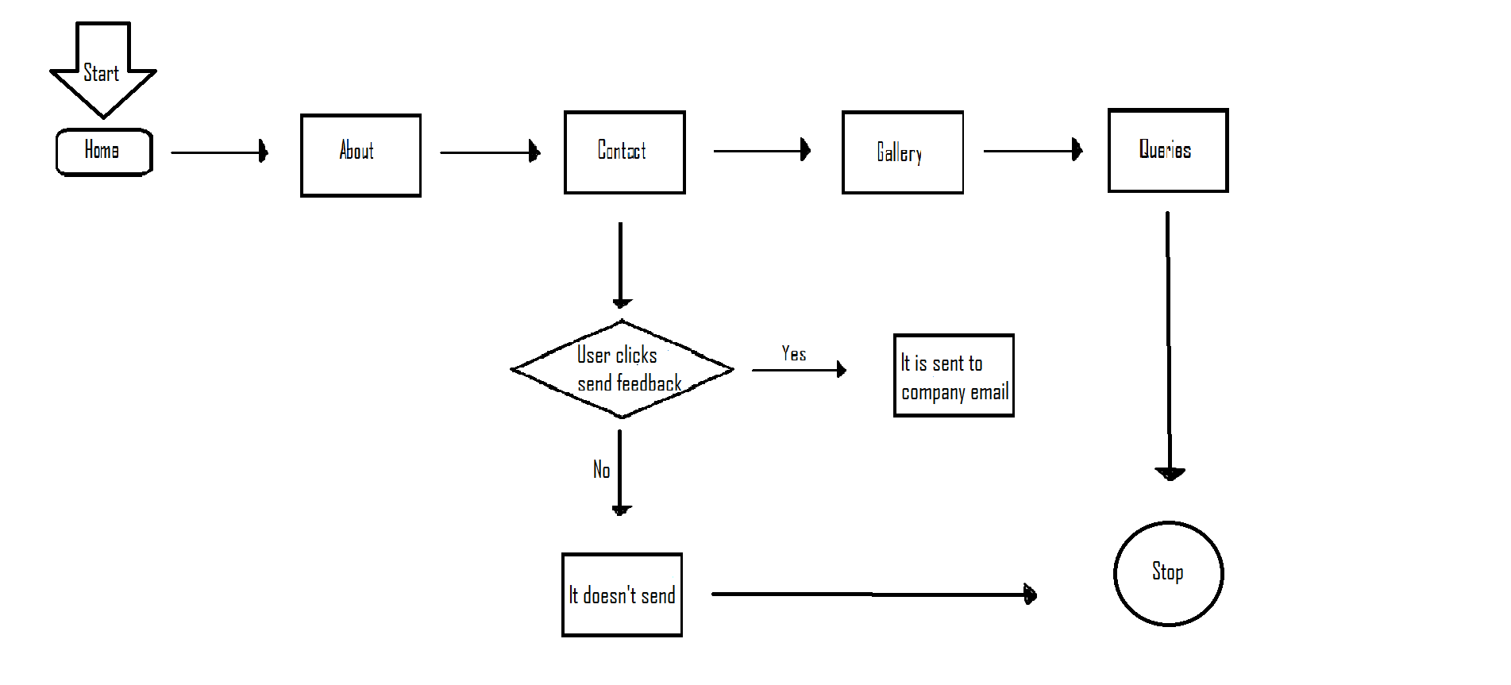

Process Diagrams:

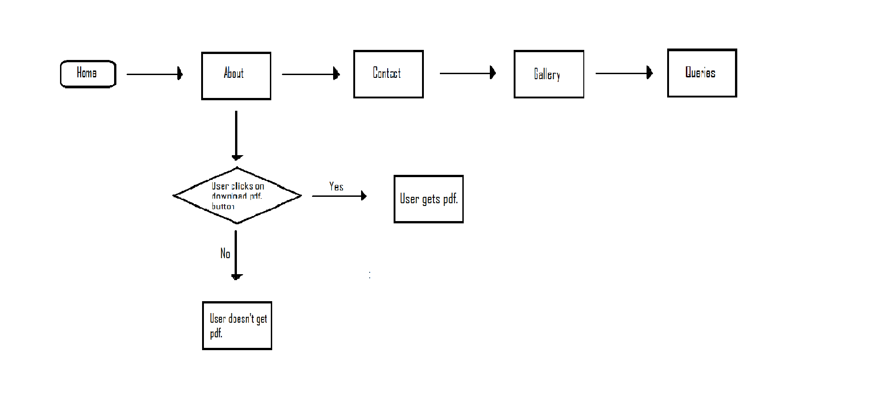

Database Design/Structure:

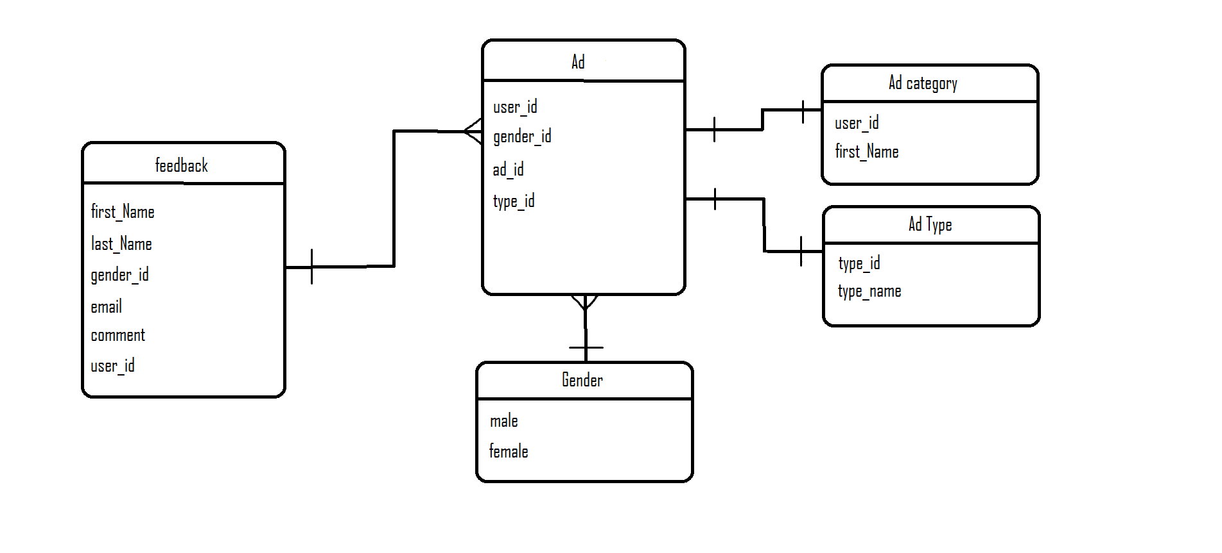

**Screenshots**

Homepage:

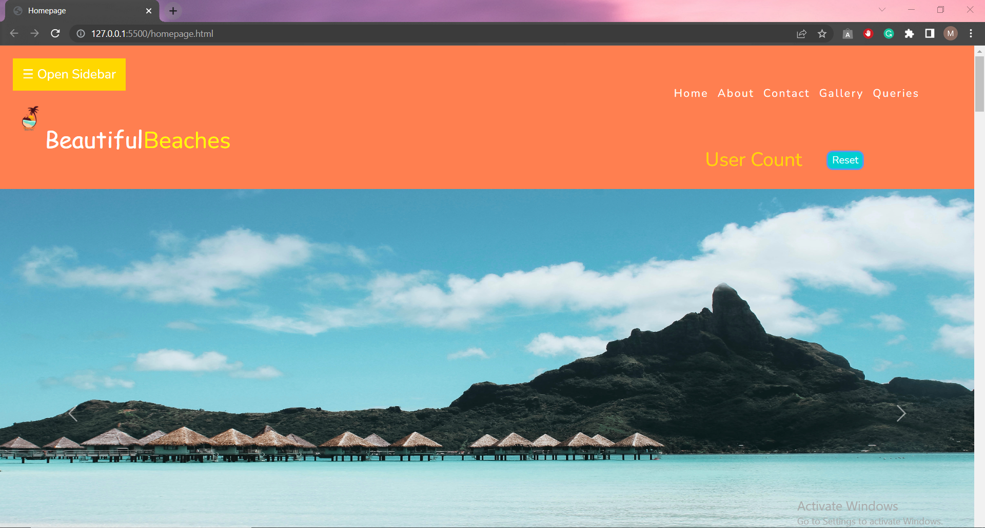

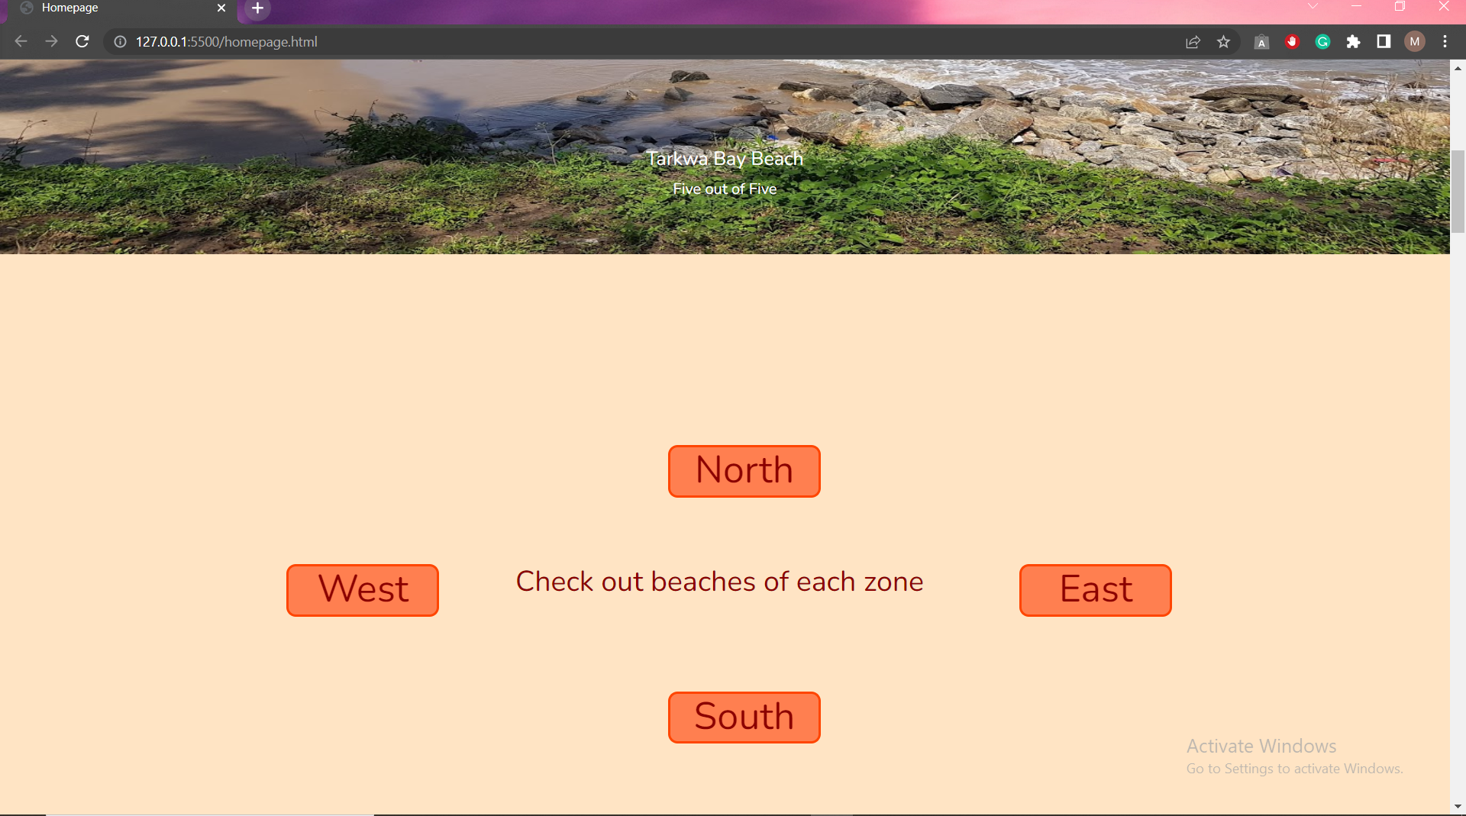

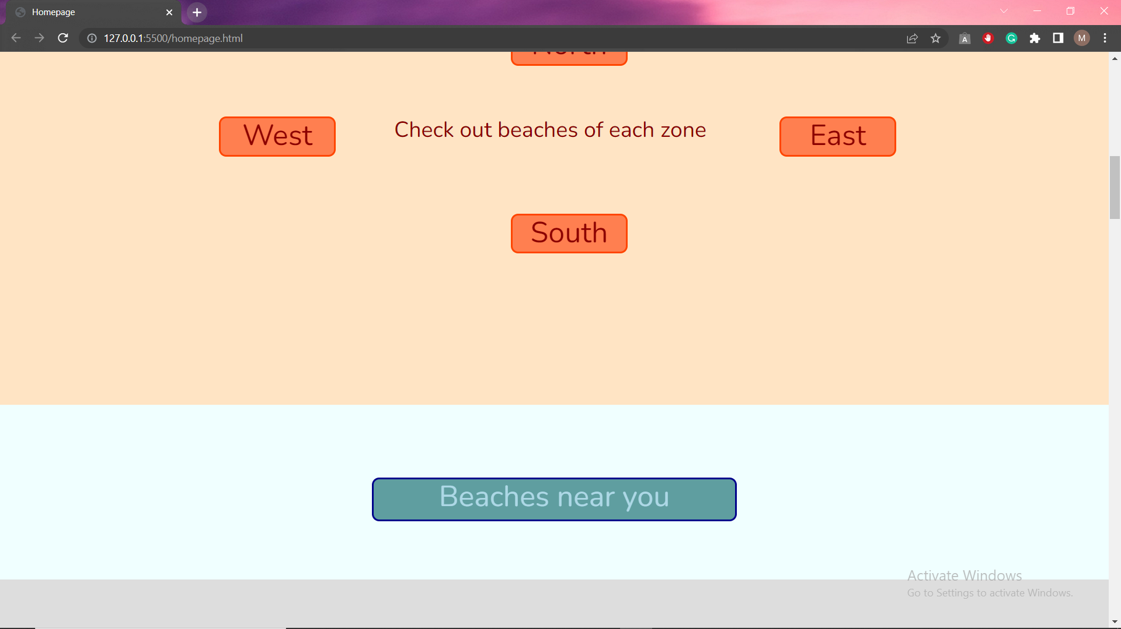

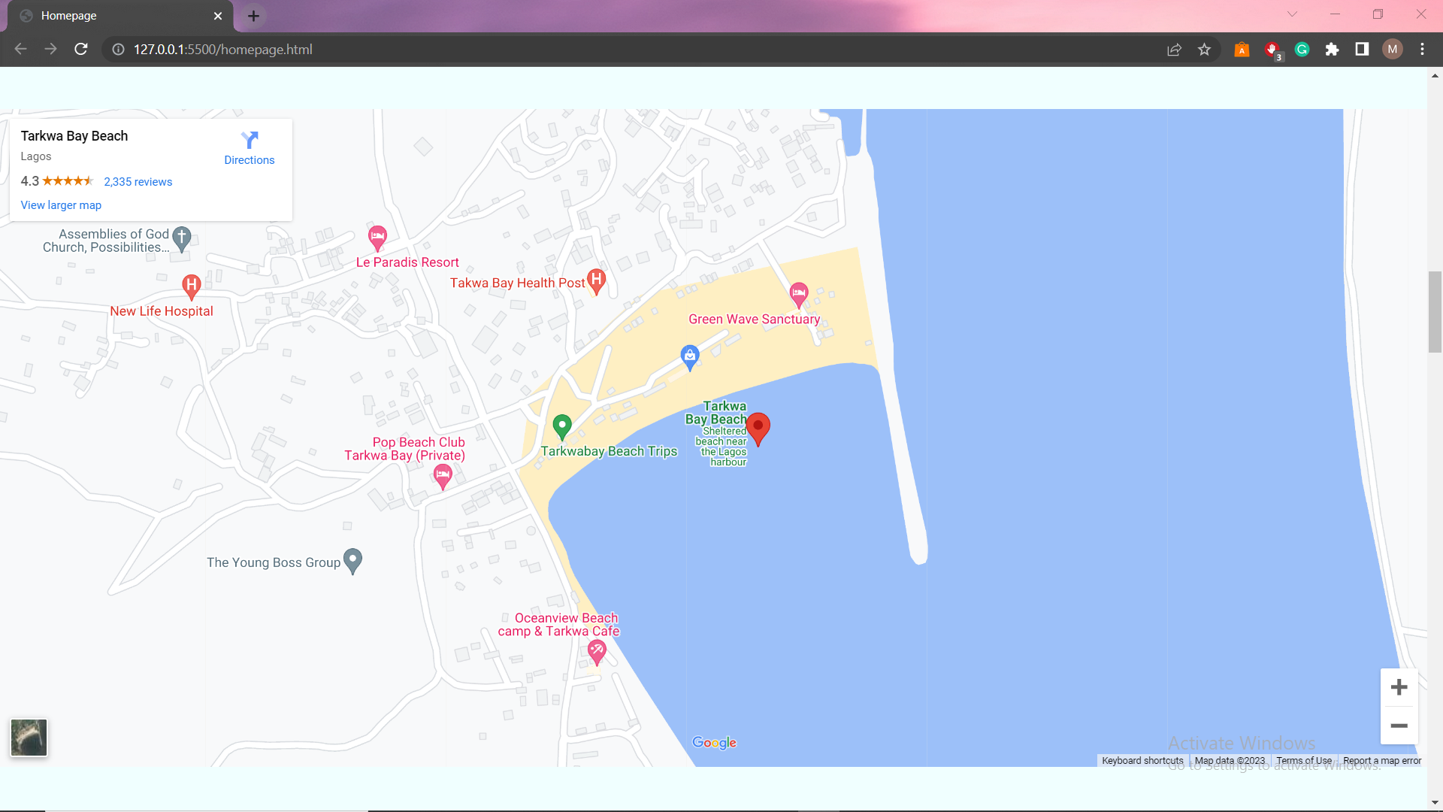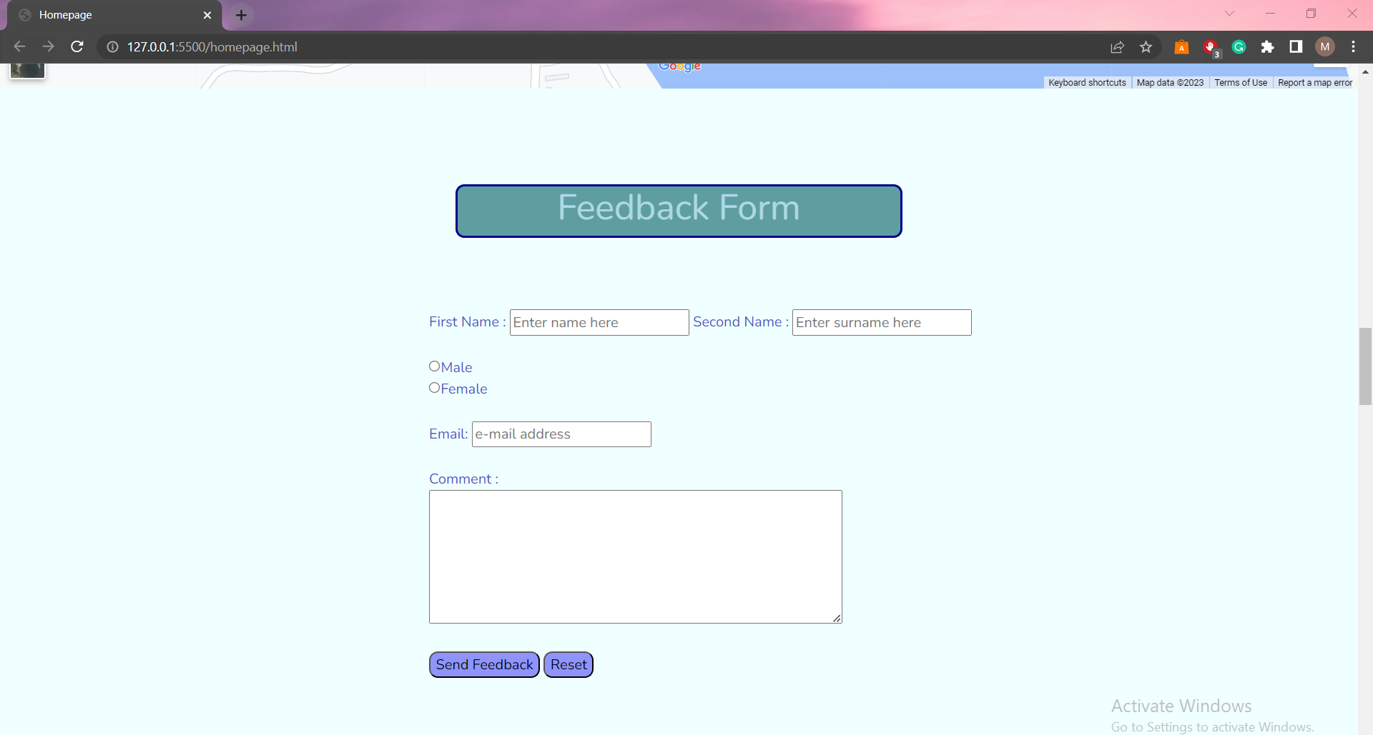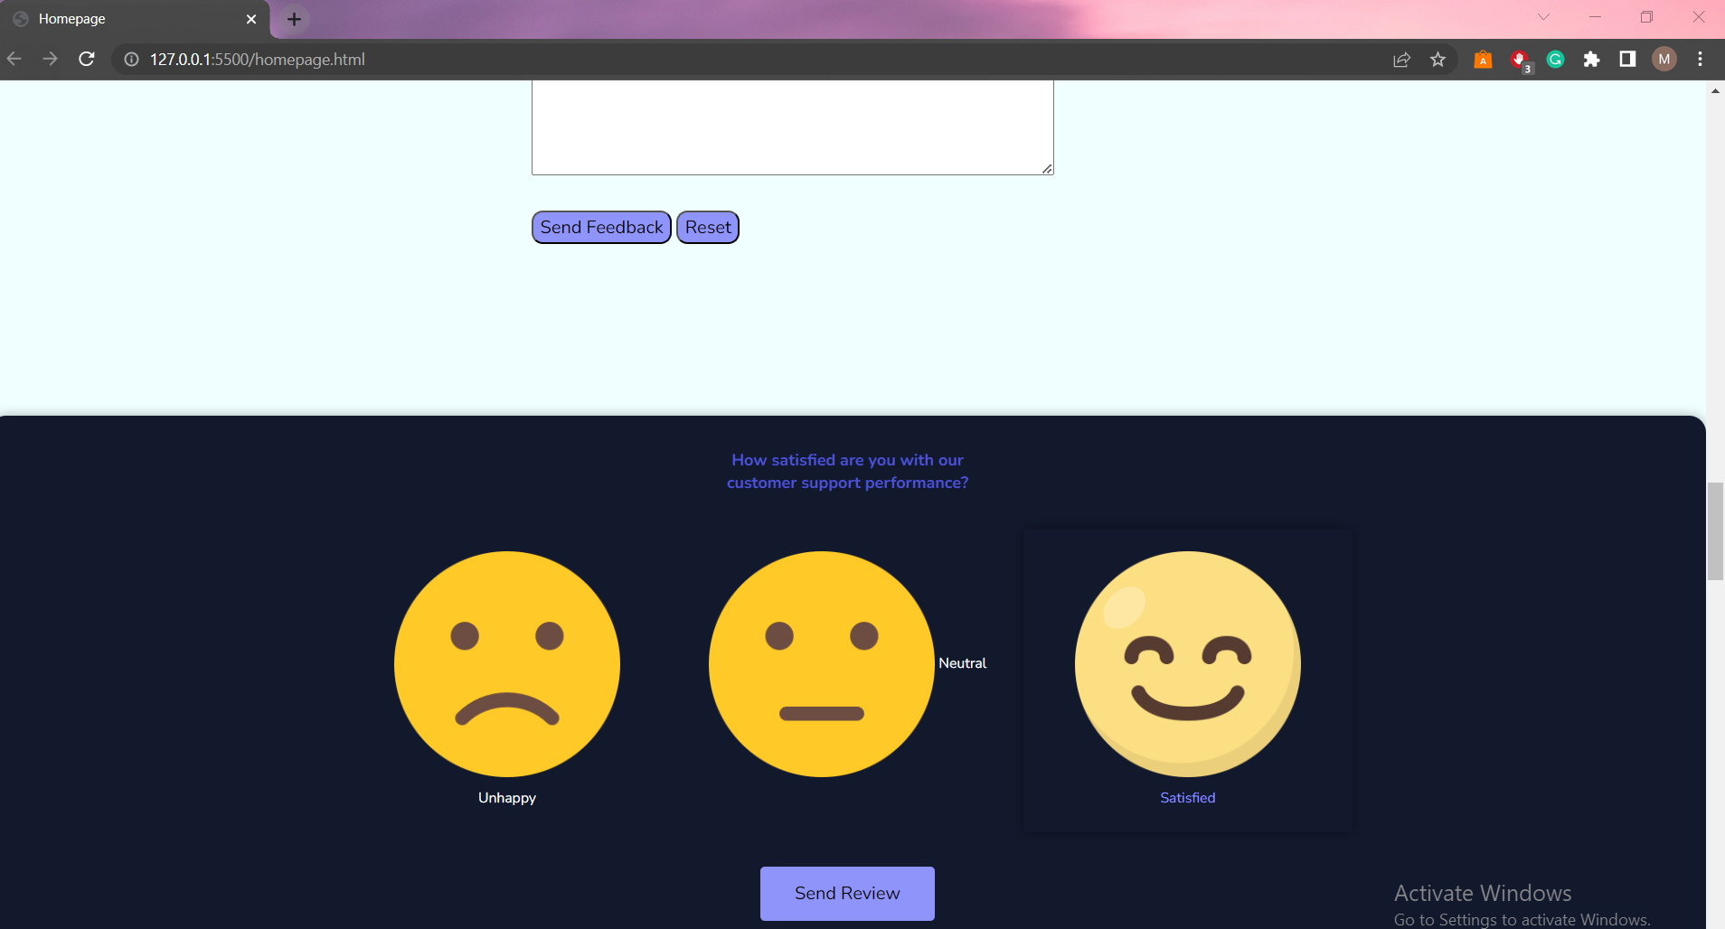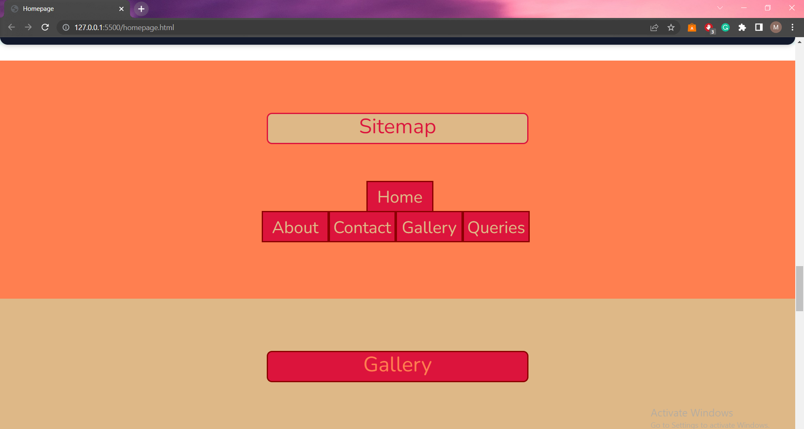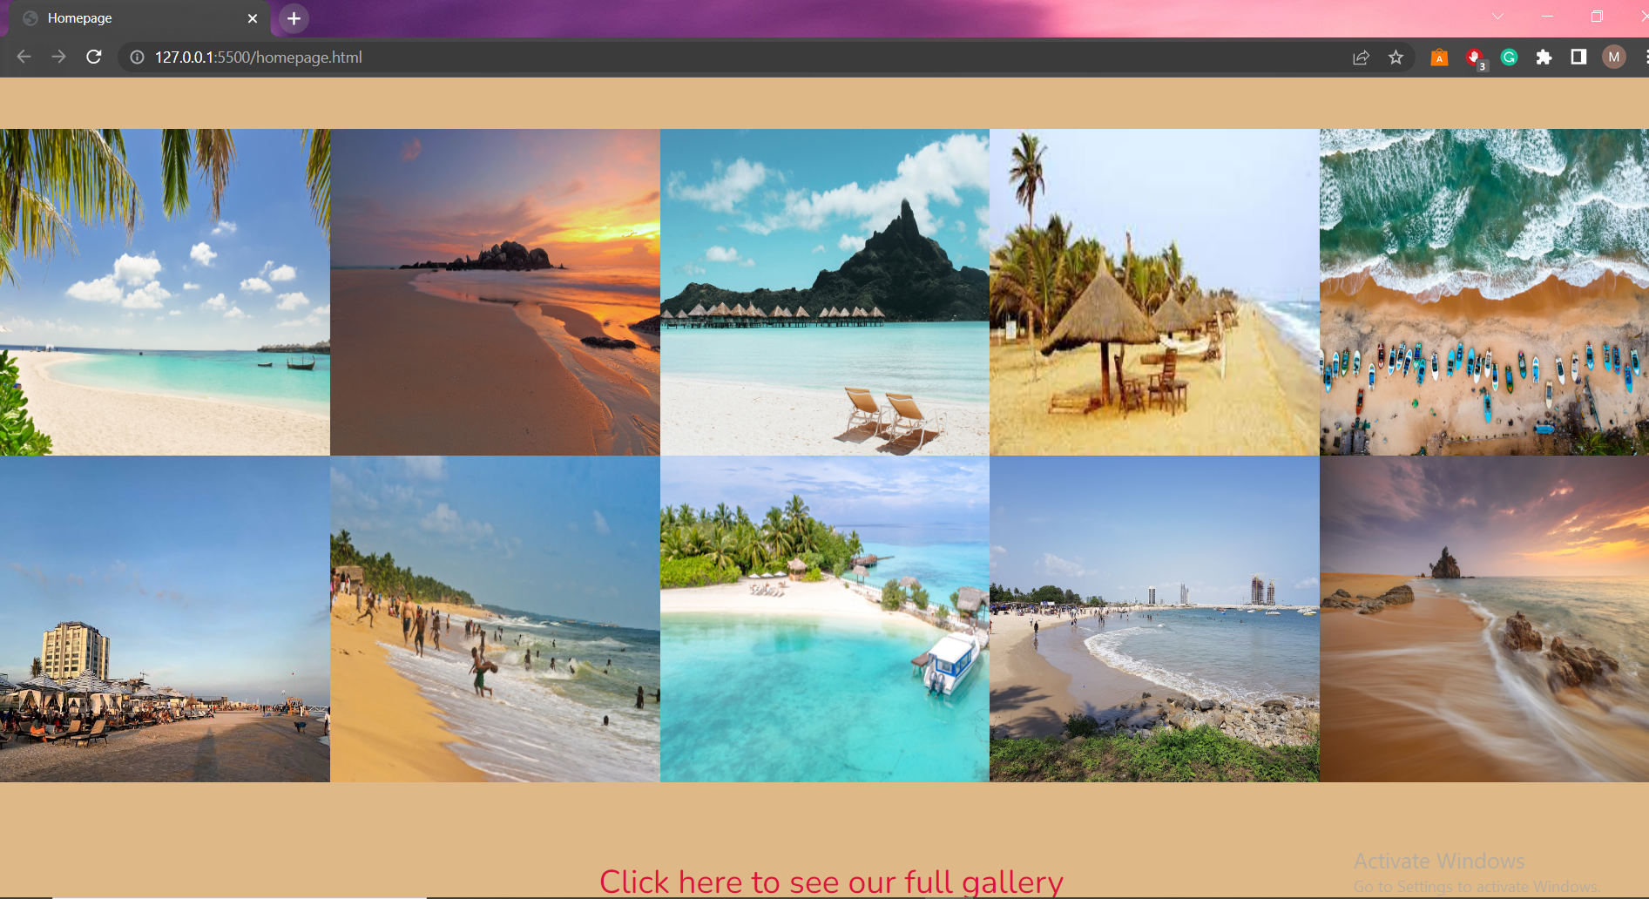

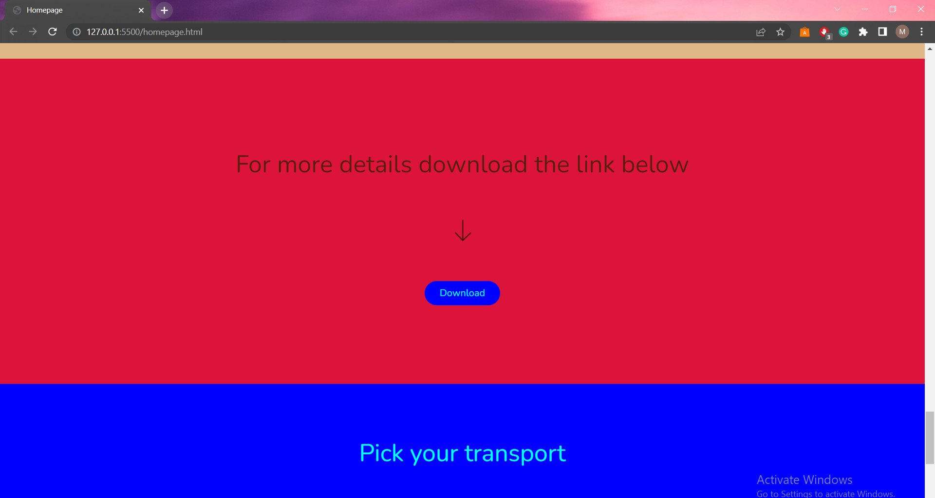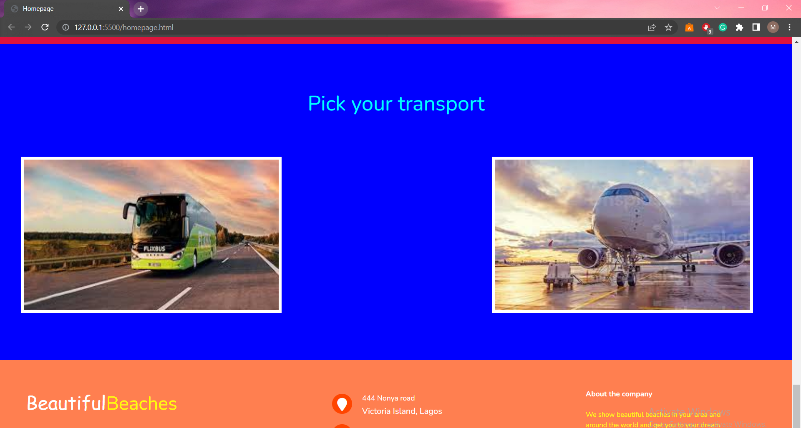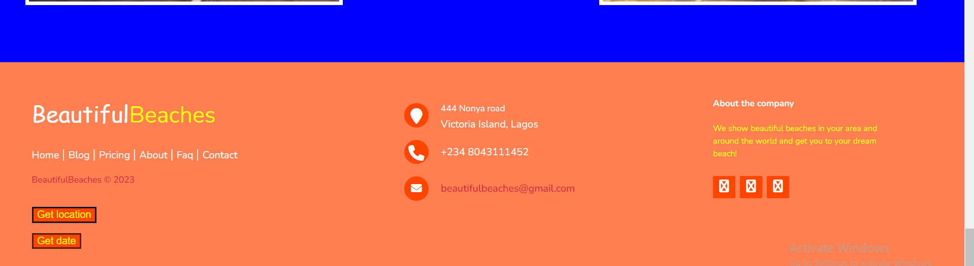

About Us:

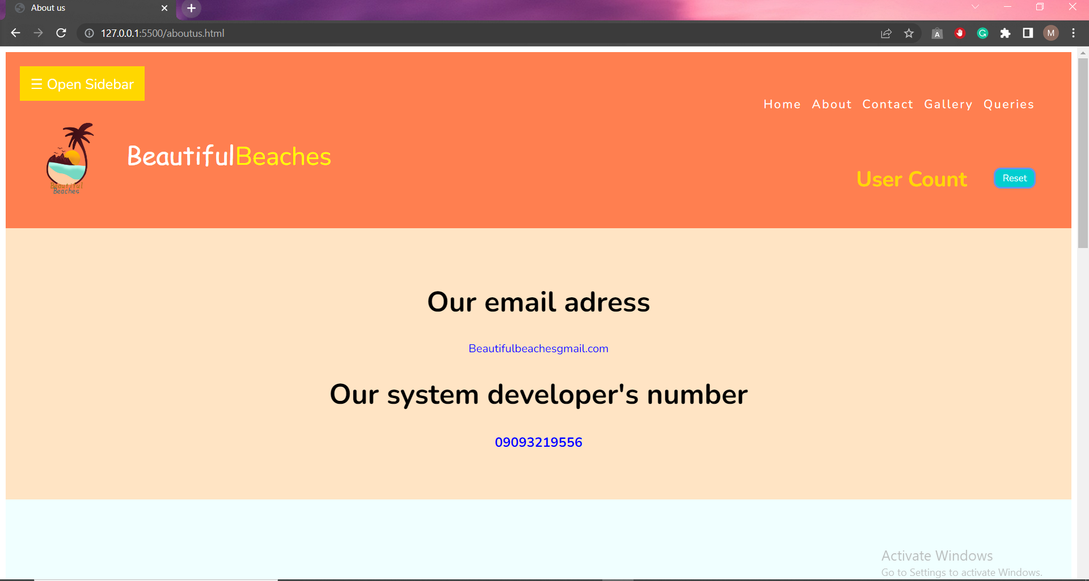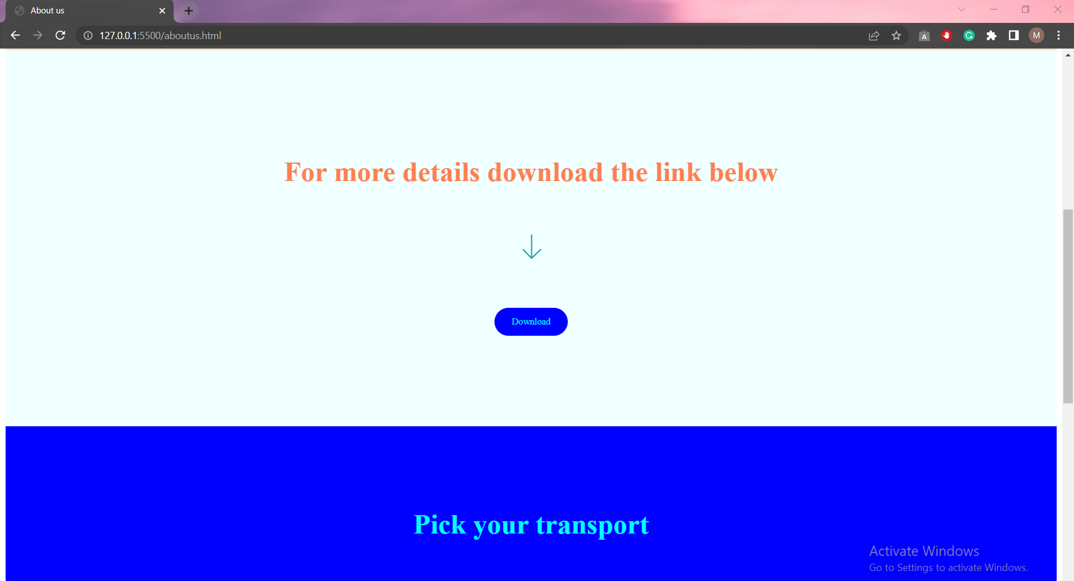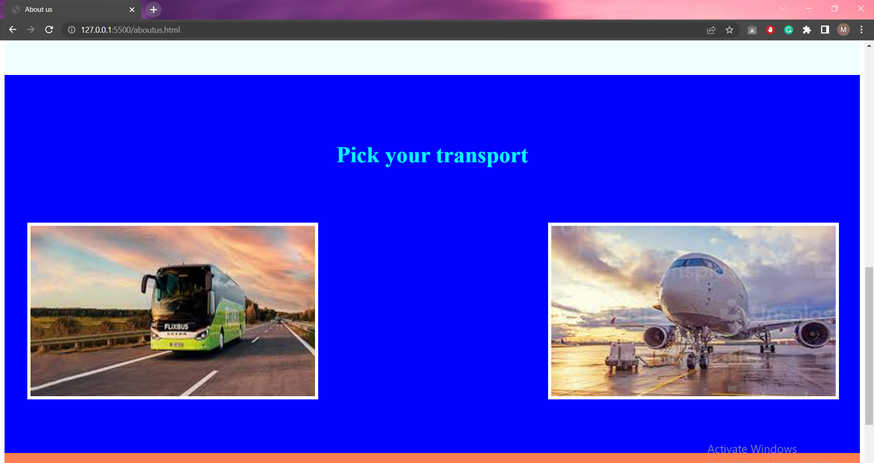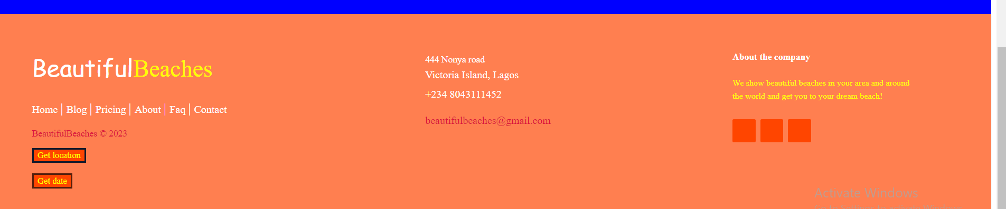

Contact Us:

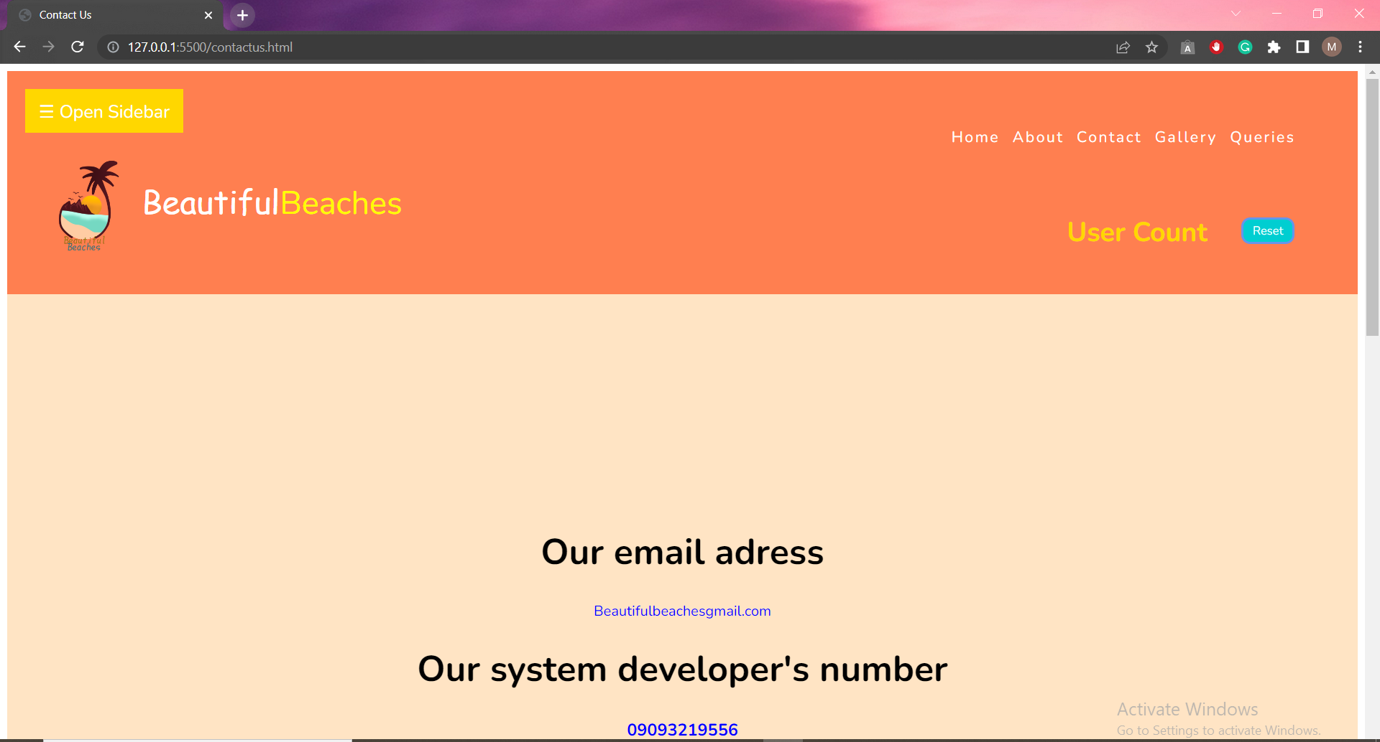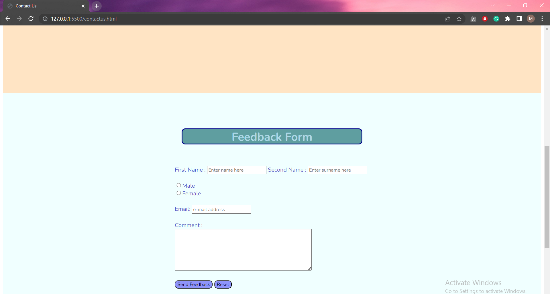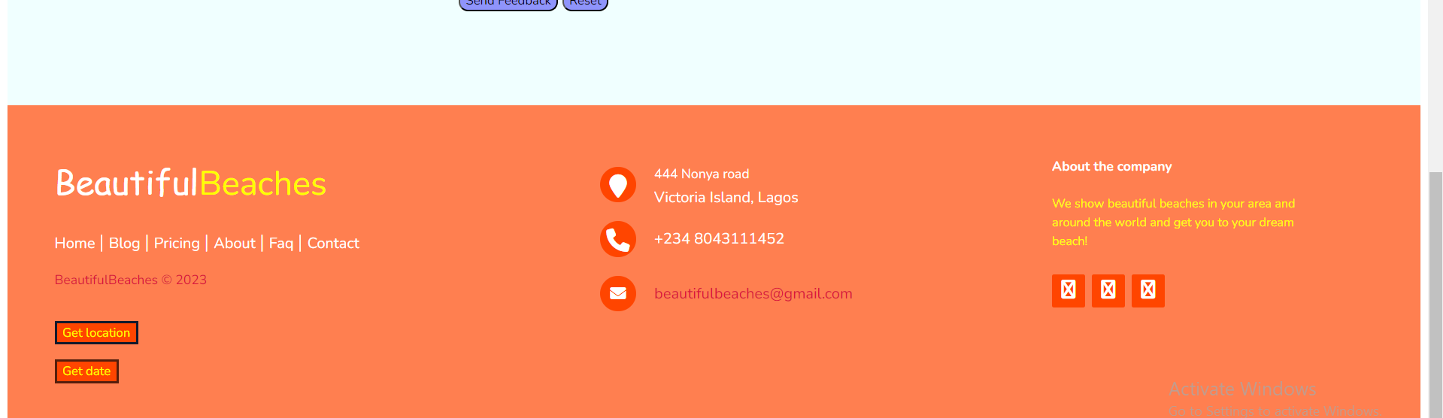

**Source Code with comments**

HTML (Homepage):

<!DOCTYPE html>

<html lang="en">

    <link rel="stylesheet" href="homepage.css">

<head>

    <meta charset="UTF-8">

    <meta http-equiv="X-UA-Compatible" content="IE=edge">

    <meta name="viewport" content="width=device-width, initial-scale=1.0">

    <link href="https://fonts.googleapis.com/css2?family=Nunito:ital,wght@0,200;0,300;0,400;0,600;0,700;0,800;0,900;1,200;1,300;1,400;1,600;1,700;1,800;1,900&display=swap" rel="stylesheet">

    <link href="https://maxcdn.bootstrapcdn.com/font-awesome/4.2.0/css/font-awesome.min.css">

    <title>Homepage</title>

    <script src="homepage.js"></script>

    <link rel="stylesheet" href="sidebar.css" />

    <!-- Fontawesome CDN Link -->

    <link rel="stylesheet" href="https://cdnjs.cloudflare.com/ajax/libs/font-awesome/6.2.1/css/all.min.css" />

    <link href="https://cdn.jsdelivr.net/npm/bootstrap@5.3.0-alpha3/dist/css/bootstrap.min.css" rel="stylesheet" integrity="sha384-KK94CHFLLe+nY2dmCWGMq91rCGa5gtU4mk92HdvYe+M/SXH301p5ILy+dN9+nJOZ" crossorigin="anonymous">

   </head>

<body>

  <!-- Sidebar -->

<div class="sidecontainer">

  <div id="mySidebar" class="sidebar">

    <a href="javascript:void(0)" class="closebtn" onclick="closeNav()">&times;</a>

    <a href="homepage.html">Home</a>

    <a href="aboutus.html">About</a>

    <a href="contactus.html">Contact</a>

    <a href="gallery.html">Gallery</a>

    <a href="queries.html">Queries</a>

  </div>

  <div id="main">

    <button class="openbtn" onclick="openNav()">&#9776; Open Sidebar</button>

  </div>

  <div class="topnav">

    <a href="homepage.html">Home</a>

    <a href="aboutus.html">About</a>

    <a href="contactus.html">Contact</a>

    <a href="gallery.html">Gallery</a>

    <a href="queries.html">Queries</a>

  </div>

</div>

    <script src="sidebar.js"></script>

<!-- Sidebar END -->

    <!-- Top section -->

    <div class="top">

        <img src="logo.png" class="logo">

        <h3>Beautiful<span>Beaches</span></h3>

        <div class="visits">

        <h1>User Count</h1>

        <div class="website-counter"></div>

        <button id="reset">Reset</button>

    </div>

</div>

    <!-- Top section END -->

   <!-- Slideshow container -->

   <div id="carouselExampleAutoplaying" class="carousel slide" data-bs-ride="carousel">

    <div class="carousel-inner">

      <div class="carousel-item active">

        <img src="beaches/cookislands.jpg" class="d-block w-100" style="width:100%">

        <div class="carousel-caption d-none d-md-block">

          <h5>Cook Islands</h5>

          <p>One out of Five</p>

        </div>

      </div>

      <div class="carousel-item">

        <img src="beaches/borabora.jpg" class="d-block w-100" style="width:100%">

        <div class="carousel-caption d-none d-md-block">

          <h5>Bora Bora Tahiti</h5>

          <p>Two out of Five</p>

        </div>

      </div>

      <div class="carousel-item">

        <img src="beaches/malibubeach.jpg" class="d-block w-100" style="width:100%">

        <div class="carousel-caption d-none d-md-block">

          <h5>Malibu Beach</h5>

          <p>Three out of Five</p>

        </div>

      </div>

      <div class="carousel-item">

        <img src="beaches/arugambeach.jpg" class="d-block w-100" style="width:100%">

        <div class="carousel-caption d-none d-md-block">

          <h5>Arugam Bay</h5>

          <p>Four out of Five</p>

        </div>

      </div>

      <div class="carousel-item">

        <img src="beaches/tarkwabaybeach.png" class="d-block w-100" style="width:100%">

        <div class="carousel-caption d-none d-md-block">

          <h5>Tarkwa Bay Beach</h5>

          <p>Five out of Five</p>

        </div>

      </div>

    </div>

    <button class="carousel-control-prev" type="button" data-bs-target="#carouselExampleAutoplaying" data-bs-slide="prev">

      <span class="carousel-control-prev-icon" aria-hidden="true"></span>

      <span class="visually-hidden">Previous</span>

    </button>

    <button class="carousel-control-next" type="button" data-bs-target="#carouselExampleAutoplaying" data-bs-slide="next">

      <span class="carousel-control-next-icon" aria-hidden="true"></span>

      <span class="visually-hidden">Next</span>

    </button>

  </div>

      <!-- Slideshow container END -->

    <!-- Zones -->

    <div class="zones">

        <h1 id="north">North</h1>

        <div class="westeast">

        <h1 id="west">West</h1>

        <h3>Check out beaches of each zone</h3>

        <h1 id="east">East</h1>

        </div>

        <h1 id="south">South</h1>

  </div>

  <!-- Zones END -->

  <!-- Geolocation -->

  <div class="geolocation">

    <h1>Beaches near you</h1>

    <div class="geofeed">

    <div id="map">

        <iframe id="google_map" src="https://www.google.com/maps/embed?pb=!1m18!1m12!1m3!1d3964.948480483766!2d3.3925091251307973!3d6.400640193590004!2m3!1f0!2f0!3f0!3m2!1i1024!2i768!4f13.1!3m3!1m2!1s0x103b8a9ebd72643b%3A0xebbd10a3b9370f70!2sTarkwa%20Bay%20Beach!5e0!3m2!1sen!2sng!4v1682969930426!5m2!1sen!2sng" width="1519" height="700" style="border:0;" allowfullscreen="" loading="lazy" referrerpolicy="no-referrer-when-downgrade"></iframe>

    </div>

    <!-- Feedback section -->

    <div class="feedback">

    <h1>Feedback Form</h1>

    <form action="mailto:beautifulbeaches@gmail.com" method="post" enctype="text/plain">

      First Name : <input type="text" name="firstname" placeholder="Enter name here">

      Second Name : <input type="text" name="secondname"  placeholder="Enter surname here">

      <br>

      <br>

      <!--It's important that both of these radio button have the same name so they behave as one component (i.e. Only one can be selected at a time)-->

      <input type="radio" name="gender" value="male">Male<br>

      <input type="radio" name="gender" value="female">Female

      <br>

      <br>

      <!--This uses the new HTML "email" INPUT type which will automatically validates the email address when the SUBMIT button is clicked-->

      Email: <input type="email" name="mail" placeholder="e-mail address">

      <br>

      <br>

        Comment :<br>

        <textarea rows="6" cols="50" name="commentfield"></textarea>

        <br>

        <br>

        <input type="submit" value="Send Feedback" class="buttoninput">

        <input type="reset" value="Reset" class="buttoninput">

    </form>

    </div>

    <!-- Review section -->

    <div class="review">

        <div id="panel" class="panel-container">

            <strong>How satisfied are you with our <br /> customer support performance?</strong>

            <div class="ratings-container">

              <div class="rating">

                <img src="sad.png" alt="">

                <small>Unhappy</small>

              </div>

              <div class="rating">

                <img src="neutral.png" alt=""/>

                <small>Neutral</small>

              </div>

              <div class="rating active">

                <img src="satisfied.png" alt=""/>

                <small>Satisfied</small>

              </div>

            </div>

            <button class="btn" id="send">Send Review</button>

          </div>

          <script src="script.js"></script>

    </div>

    </div>

  </div>

  <!-- Geolocation END -->

  <!-- Sitemap -->

  <div class="sitemap">

    <h1>Sitemap</h1>

    <h2 id="above">Home</h2>

    <div class="under">

      <h2>About</h2>

      <h2>Contact</h2>

      <h2>Gallery</h2>

      <h2>Queries</h2>

    </div>

  </div>

  <!-- Sitemap END -->

  <!-- Gallery -->

  <div class="gallery">

    <h1>Gallery</h1>

    <div class="rows">

    <div class="rowtwo">

    <img src="beaches/cookislands.jpg" alt="beach1" style="width:303px; height:300px;">

    <img src="beaches/malibubeach.jpg" alt="beach2" style="width:303px; height:300px;">

    <img src="beaches/borabora.jpg" alt="beach3" style="width:303px; height:300px;">

    <img src="beaches/calabarbeach.png" alt="beach4" style="width:303px; height:300px;">

    <img src="beaches/arugambeach.jpg" alt="beach5" style="width:303px; height:300px;">

    </div>

    <div class="rowtwo">

    <img src="beaches/landmarkbeach.png" alt="beach6" style="width:303px; height:300px;">

    <img src="beaches/lekkibeach.png" alt="beach7" style="width:303px; height:300px;">

    <img src="beaches/miamibeach.jpg" alt="beach8" style="width:303px; height:300px;">

    <img src="beaches/tarkwabaybeach.png" alt="beach9" style="width:303px; height:300px;">

    <img src="beaches/thailandbeach.jpg" alt="beach10" style="width:303px; height:300px;">

    </div>

    </div>

    <a href="gallery.html">Click here to see our full gallery</a>

  </div>

  <!-- Gallery END -->

   <!-- Download -->

  <div class="pdfdownload">

    <h1>For more details download the link below</h1>

    <svg xmlns="http://www.w3.org/2000/svg" viewBox="0 0 64 64" stroke-width="2.5" stroke="#461707" fill="none" class="duration-300 transform transition-all" style="width: 48px; height: 48px;"><path d="M32.4 54.7V9.25M50.41 37.47L32.25 54.7 15.71 37.47"></path></svg>

    <div class="download">

        <form>

        <a href="Beautiful Beaches.pdf" download>

            <input type="button" value="Download"></a>

            </form>

    </div>

 </div>

 <div class="transport">

    <h1>Pick your transport</h1>

    <div class="img">

    <img src="bus.png" alt="bus" class="bus">

    <img src="plane.png" alt="plane" class="plane">

 </div>

 </div>

  <!-- Downnload END -->

<!-- Footer  -->

<footer class="footer-distributed">

      <div class="footer-left">

        <h3>Beautiful<span>Beaches</span></h3>

        <p class="footer-links">

          <a href="#" class="link-1">Home</a>

          <a href="#">Blog</a>

          <a href="#">Pricing</a>

          <a href="aboutus.html">About</a>

          <a href="#">Faq</a>

          <a href="contactus.html">Contact</a>

        </p>

        <p class="footer-company-name">BeautifulBeaches © 2023</p>

      </div>

      <div class="footer-center">

        <div>

          <i class="fa fa-map-marker"></i>

          <p><span>444 Nonya road</span> Victoria Island, Lagos</p>

        </div>

        <div>

          <i class="fa fa-phone"></i>

          <p>+234 8043111452</p>

        </div>

        <div>

          <i class="fa fa-envelope"></i>

          <p><a href="mailto:beautifulbeaches@gmail.com">beautifulbeaches@gmail.com</a></p>

        </div>

      </div>

      <div class="footer-right">

        <p class="footer-company-about">

          <span>About the company</span>

          We show beautiful beaches in your area and around the world and get you to your dream beach!

        </p>

        <div class="footer-icons">

          <a href="https://icons.theforgesmith.com"><i class="fa fa-facebook"></i></a>

          <a href="https://icons.theforgesmith.com"><i class="fa fa-twitter"></i></a>

          <a href="https://icons.theforgesmith.com"><i class="fa fa-linkedin"></i></a>

        </div>

      </div>

<!-- Footer END -->

<!-- Ticker -->

<button class="location" onclick="getlocation()">

  Get location

</button>

<p id="demo1"></p>

<script>

  var variable1 = document.getElementById("demo1");

  function getlocation() {

      navigator.geolocation.getCurrentPosition(showLoc);

  }

  function showLoc(pos) {

      variable1.innerHTML =

          "Latitude: " +

          pos.coords.latitude +

          "<br>Longitude: " +

          pos.coords.longitude;

  }

  </script>

<button type="button" onclick="myFunction()" class="date">Get date</button>

<script>

function myFunction()

{

document.getElementById("display").innerHTML = Date();

}

</script>

<p id="display"></p>

<!-- Ticker END -->

<script src="https://cdn.jsdelivr.net/npm/bootstrap@5.3.0-alpha3/dist/js/bootstrap.bundle.min.js" integrity="sha384-ENjdO4Dr2bkBIFxQpeoTz1HIcje39Wm4jDKdf19U8gI4ddQ3GYNS7NTKfAdVQSZe" crossorigin="anonymous"></script>

</body>

</html>

CSS (Homepage):

@import url('https://fonts.googleapis.com/css?family=Montserrat&display=swap');

*{

    font-family: 'Nunito';

}

html {

  scroll-behavior: smooth;

}

img {

    width: 100px;

    height: 700px;

}

/* The container */

.sidecontainer{

  background-color: coral;

  display:flex;

}

.topnav{

  margin-left: 830px;

  margin-top: 62px;

}

.topnav a{

  color:white;

  text-decoration: none;

  letter-spacing: 2px;

  margin-left: 5px;

  margin-right: 5px;

  font-size: 17px;

}

.topnav a:hover{

  color:yellow;

  transition: 0.3s ease-in-out;

}

/* Top section */

.top {

    display: flex;

    z-index: 1;

    background-color: coral;

    width: 100%;

    padding-bottom: 30px;

}

.logo {

    width: 130px;

    height: 130px;

    margin-left: 20px;

}

.top h3{

  color:  #ffffff;

  font: normal 36px 'Open Sans', cursive;

  margin-top: 30px;

}

.top h3 span{

  color:  yellow;

}

.visits{

  margin-top: 50px;

  display: flex;

}

.top h1{

   margin-left: 740px;

    margin-top: 20px;

    color:gold;

    font-size: 30px;

    margin-bottom: -25px;

}

.visits button{

  margin-left: 38px;

  margin-top: 24px;

  background-color:darkturquoise;

  color:azure;

  border:cornflowerblue 3px solid;

  width: 59px;

  height: 30px;

  padding-top: -2px;

  border-radius: 10px;

}

.visits button:hover{

  cursor: pointer;

  background-color: azure;

  color: darkturquoise;

  border: cornflowerblue 3px solid;

  transition: 0.3s ease-in-out;

}

/* Top section END */

/* Zones */

.zones{

    background-color: bisque;

    padding-top: 200px;

    padding-bottom: 200px;

}

.zones h1{

    background-color:coral;

    width: 160px;

    height: 55px;

    padding-left: 20px;

    padding-right: 20px;

    border-radius: 10px;

    border: orangered 3px solid;

    color:darkred;

    text-align:center;

}

.zones h1:hover{

    cursor: pointer;

    background-color:lightcoral;

    border: orange 5px solid;

    color:white;

    transition: 0.3s ease-in-out;

}

.zones h3{

    color:darkred;

    font-size: 30px;

    margin-left: 80px;

    margin-right: -100px;

    text-align: center;

}

#north{

  text-align: center;

    margin-left: 700px;

}

.westeast{

    display: flex;

    margin-top: 70px;

    margin-bottom: 70px;

}

#west{

    text-align: center;

    margin-left: 300px;

}

#east{

    text-align: center;

    margin-left: 200px;

}

#south{

    text-align: center;

    margin-left: 700px;

}

/* Zones END */

/* Geolocation */

.geolocation{

    background-color:azure;

    padding-top: 100px;

    padding-bottom: -40px;

}

.geolocation h1{

    background-color: cadetblue;

    color:lightblue;

    width: 500px;

    height: 60px;

    border-radius: 10px;

    border: darkblue 3px solid;

    margin:auto;

    text-align: center;

}

#map{

    margin-top: 80px;

    margin-bottom: 40px;

    margin-left: 300pcx;

}

/* Feedback */

.feedback h1{

  margin-top: 100px;

  margin-bottom: 80px;

}

.feedback form{

  margin-left: 480px;

  color:#4e54c8;

}

.buttoninput{

  background-color: #8f94fb;

  color: #000;

  border-radius: 10px;

}

.buttoninput:hover{

  cursor: pointer;

  background-color: #000;

  color:#8f94fb;

  transition: ease-in-out 0.3s;

}

/* Review */

.panel-container {

    background-color: #12192c;

    box-shadow: 0 0 10px rgba(0, 0, 0, 0.3);

    border-radius: 15px;

    font-size: 90%;

    display: flex;

    flex-direction: column;

    justify-content: center;

    align-items: center;

    text-align: center;

    padding: 30px;

    color:#4e54c8;

    margin:10% auto 2% auto;

  }

  .panel-container strong {

    line-height: 20px;

  }

  .ratings-container {

    display: flex;

    margin: 20px 0;

  }

  .rating {

    flex: 1;

    cursor: pointer;

    padding: 20px;

    margin: 10px 5px;

  }

  .rating:hover,

  .rating.active {

    border-radius: 4px;

    box-shadow: 0 0 10px rgba(0, 0, 0, 0.4);

    transition: ease-in-out 0.2s;

  }

  .rating img {

    width: 200px;

    height: 200px;

  }

  .rating small {

    color: #fff;

    display: inline-block;

    margin: 10px 0 0;

  }

  .rating:hover small,

  .rating.active small {

    color: #8f94fb;

  }

  .review button{

    background-color: #8f94fb;

    color: #000;

    border: 0;

    border-radius: 4px;

    padding: 12px 30px;

    cursor: pointer;

  }

  .btn:focus {

    outline: 0;

  }

  .btn:active {

    transform: scale(0.98);

  }

    .geofeed{

      margin-top: 30px;

    }

    .btn:hover{

      background-color:#000;

      color:#8f94fb;

      transition: ease-in-out 0.3s;

    }

/* Geolocation END */

/* Sitemap */

.sitemap{

  background-color: coral;

  padding-top: 100px;

  padding-bottom: 100px;

}

.sitemap h1{

  background-color: burlywood;

  color:crimson;

  width: 500px;

  height: 60px;

  border-radius: 10px;

  border: crimson 3px solid;

  margin:auto;

  text-align: center;

}

.sitemap h2{

  background-color: crimson;

  color:burlywood;

  border: darkred 3px solid;

  text-align: center;

  width: 128px;

  height: 60px;

  padding-top: 10px;

  padding-bottom: 10px;

}

#above{

  margin-top: 70px;

  margin-left: 700px;

  margin-bottom: -2px;

}

.under{

  display: flex;

  margin-left: 500px;

}

/* Sitemap END */

/* Gallery */

.gallery{

  background-color:burlywood;

  padding-top: 100px;

  padding-bottom: 100px;

}

.gallery h1{

  background-color: crimson;

  color:coral;

  width: 500px;

  height: 60px;

  border-radius: 10px;

  border: darkred 3px solid;

  margin:auto;

  text-align: center;

  margin-bottom: 90px;

}

.rowtwo{

  display: flex;

}

.rows{

  margin-bottom: 70px;

}

.gallery a{

  text-decoration: none;

  font-size: 30px;

  color:crimson;

  margin-left: 550px;

}

.gallery h2:hover{

  cursor: pointer;

  color: white;

  transition: 0.3s ease-in-out;

}

/* Gallery END */

/* Download */

.pdfdownload{

  background-color:crimson;

  text-align: center;

  padding-top: 90px;

  padding-bottom: 90px;

}

.pdfdownload h1{

  margin-top: 60px;

  margin-bottom: 60px;

  font-size: 40px;

  color:#551E0C;

}

.download{

  margin-top: 60px;

  margin-bottom: 40px;

}

.download input{

  padding: 10px 25px;

  line-height: 20px;

  min-width: 80px;

  cursor: pointer;

  border: none;

  background-color: blue;

  color: cyan;

  border-radius: 20px;

}

.download input:hover{

  background-color: cyan;

  color:blue;

  transition: 0.3s ease-in-out;

}

.transport{

  background-color: blue;

  padding-top: 90px;

  padding-bottom: 90px;

  color:aqua;

}

.transport h1{

  text-align: center;

  font-size: 40px;

}

.bus{

  width: 500px;

  height: 300px;

  margin-top: 70px;

  margin-left: 40px;

  margin-right: 310px;

  border: 6px solid white

}

.plane{

      width: 500px;

      height: 300px;

      margin-top: 70px;

      margin-left: 90px;

      text-align: right;

      border: 6px solid white;

}

.bus:hover{

  cursor: pointer;

  border: 2px solid white;

  transition: 0.3s ease-in-out;

}

.plane:hover{

  cursor: pointer;

  border: 2px solid white;

  transition: 0.3s ease-in-out;

}

/* Download END */

/* Footer */

.footer-distributed{

  background: coral;

  box-shadow: 0 1px 1px 0 rgba(0, 0, 0, 0.12);

  box-sizing: border-box;

  width: 100%;

  text-align: left;

  font: bold 16px sans-serif;

  padding: 55px 50px;

}

.footer-distributed .footer-left,

.footer-distributed .footer-center,

.footer-distributed .footer-right{

  display: inline-block;

  vertical-align: top;

}

/* Footer left */

.footer-distributed .footer-left{

  width: 40%;

}

/* The company logo */

.footer-distributed h3{

  color:  #ffffff;

  font: normal 36px 'Open Sans', cursive;

  margin: 0;

}

.footer-distributed h3 span{

  color:  yellow;

}

/* Footer links */

.footer-distributed .footer-links{

  color:  #ffffff;

  margin: 20px 0 12px;

  padding: 0;

}

.footer-distributed .footer-links a{

  display:inline-block;

  line-height: 1.8;

  font-weight:400;

  text-decoration: none;

  color:  inherit;

}

.footer-distributed .footer-company-name{

  color:  crimson;

  font-size: 14px;

  font-weight: normal;

  margin: 0;

}

/* Footer Center */

.footer-distributed .footer-center{

  width: 35%;

}

.footer-distributed .footer-center i{

  background-color:  orangered;

  color: #ffffff;

  font-size: 25px;

  width: 38px;

  height: 38px;

  border-radius: 50%;

  text-align: center;

  line-height: 42px;

  margin: 10px 15px;

  vertical-align: middle;

}

.footer-distributed .footer-center i.fa-envelope{

  font-size: 17px;

  line-height: 38px;

}

.footer-distributed .footer-center p{

  display: inline-block;

  color: #ffffff;

  font-weight:400;

  vertical-align: middle;

  margin:0;

}

.footer-distributed .footer-center p span{

  display:block;

  font-weight: normal;

  font-size:14px;

  line-height:2;

}

.footer-distributed .footer-center p a{

  color:  crimson;

  text-decoration: none;;

}

.footer-distributed .footer-links a:before {

  content: "|";

  font-weight:300;

  font-size: 20px;

  left: 0;

  color: #fff;

  display: inline-block;

  padding-right: 5px;

}

.footer-distributed .footer-links .link-1:before {

  content: none;

}

/* Footer Right */

.footer-distributed .footer-right{

  width: 20%;

}

.footer-distributed .footer-company-about{

  line-height: 20px;

  color:  yellow;

  font-size: 13px;

  font-weight: normal;

  margin: 0;

}

.footer-distributed .footer-company-about span{

  display: block;

  color:  #ffffff;

  font-size: 14px;

  font-weight: bold;

  margin-bottom: 20px;

}

.footer-distributed .footer-icons{

  margin-top: 25px;

}

.footer-distributed .footer-icons a{

  display: inline-block;

  width: 35px;

  height: 35px;

  cursor: pointer;

  background-color:  orangered;

  border-radius: 2px;

  font-size: 20px;

  color: #ffffff;

  text-align: center;

  line-height: 35px;

  margin-right: 3px;

  margin-bottom: 5px;

}

/* Responsive footer */

@media (max-width: 880px) {

  .footer-distributed{

    font: bold 14px sans-serif;

  }

  .footer-distributed .footer-left,

  .footer-distributed .footer-center,

  .footer-distributed .footer-right{

    display: block;

    width: 100%;

    margin-bottom: 40px;

    text-align: center;

  }

  .footer-distributed .footer-center i{

    margin-left: 0;

  }

}

/* Footer END */

/* Ticker */

.location{

  background-color: orangered;

  color: yellow;

  border: #12192c 3px solid;

}

.date{

  background-color: orangered;

  color: yellow;

  border:#551E0C 3px solid;

}

/* Ticker END */

Javascript (Homepage):

//Visitor Count

var counterContainer = document.querySelector(".website-counter");

var resetButton = document.querySelector("#reset");

var visitCount = localStorage.getItem("page_view");

// Check if page_view entry is present

if (visitCount) {

  visitCount = Number(visitCount) + 1;

  localStorage.setItem("page_view", visitCount);

} else {

  visitCount = 1;

  localStorage.setItem("page_view", 1);

}

counterContainer.innerHTML = visitCount;

// Adding onClick event listener

resetButton.addEventListener("click", () => {

  visitCount = 1;

  localStorage.setItem("page_view", 1);

  counterContainer.innerHTML = visitCount;

});

//Visitor Count END

//Geolocation

//Feedback

const ratings = document.querySelectorAll('.rating')

const ratingsContainer = document.querySelector('.ratings-container')

const sendBtn = document.querySelector('#send')

const panel = document.querySelector('#panel')

let selectedRating = 'Satisfied'

ratingsContainer.addEventListener('click', (e) => {

    if(e.target.parentNode.classList.contains('rating')) {

        removeActive()

        e.target.parentNode.classList.add('active')

        selectedRating = e.target.nextElementSibling.innerHTML

    }

    if(e.target.classList.contains('rating')) {

        removeActive()

        e.target.classList.add('active')

        selectedRating = e.target.nextElementSibling.innerHTML

    }

})

sendBtn.addEventListener('click', (e) => {

    panel.innerHTML = `

        Thank You!

        Feedback : ${selectedRating}

        We'll use your feedback to improve our customer support

    `

})

function removeActive() {

    for(let i = 0; i < ratings.length; i++) {

        ratings[i].classList.remove('active')

    }

}

// Ticker

$(

  function() {

    $('#time').click(function() {

      var time = moment().format('YYYY-MM-DDThh:mm:ss');

      $('#time-holder').val(time);

    });

  }

);

// Ticker END

Sidebar code:

/* The sidebar menu */

.sidebar {

  height: 100%; /* 100% Full-height */

  width: 0; /* 0 width - change this with JavaScript */

  position: fixed; /* Stay in place */

  z-index: 1; /* Stay on top */

  top: 0;

  left: 0;

  background-color: gold; /* Black*/

  overflow-x: hidden; /* Disable horizontal scroll */

  padding-top: 60px; /* Place content 60px from the top */

  transition: 0.5s; /* 0.5 second transition effect to slide in the sidebar */

}

/* The sidebar links */

.sidebar a {

  padding: 8px 8px 8px 32px;

  text-decoration: none;

  font-size: 25px;

  color: coral;

  display: block;

  transition: 0.3s;

}

/* When you mouse over the navigation links, change their color */

.sidebar a:hover {

  color: white;

}

/* Position and style the close button (top right corner) */

.sidebar .closebtn {

  position: absolute;

  top: 0;

  right: 25px;

  font-size: 36px;

  margin-left: 50px;

}

/* The button used to open the sidebar */

.openbtn {

  font-size: 20px;

  cursor: pointer;

  background-color: gold;

  color: white;

  padding: 10px 15px;

  border: none;

}

.openbtn:hover {

  background-color: lightgoldenrodyellow;

  color: gold;

}

/* Style page content - use this if you want to push the page content to the right when you open the side navigation */

#main {

  transition: margin-left .5s; /* If you want a transition effect */

  padding: 20px;

}

/* On smaller screens, where height is less than 450px, change the style of the sidenav (less padding and a smaller font size) */

@media screen and (max-height: 450px) {

  .sidebar {padding-top: 15px;}

  .sidebar a {font-size: 18px;}

}

HTML (About):

<!DOCTYPE html>

<html lang="en">

    <link rel="stylesheet" href="aboutus.css">

<head>

    <meta charset="UTF-8">

    <meta http-equiv="X-UA-Compatible" content="IE=edge">

    <meta name="viewport" content="width=device-width, initial-scale=1.0">

    <link href="https://fonts.googleapis.com/css2?family=Nunito:ital,wght@0,200;0,300;0,400;0,600;0,700;0,800;0,900;1,200;1,300;1,400;1,600;1,700;1,800;1,900&display=swap" rel="stylesheet">

    <title>About us</title>

    <link rel="stylesheet" href="sidebar.css" />

     <!-- Fontawesome CDN Link -->

     <link rel="stylesheet" href="https://cdnjs.cloudflare.com/ajax/libs/font-awesome/6.2.1/css/all.min.css" />

</head>

<body>

     <!-- Sidebar -->

<div class="sidecontainer">

    <div id="mySidebar" class="sidebar">

      <a href="javascript:void(0)" class="closebtn" onclick="closeNav()">&times;</a>

      <a href="homepage.html">Home</a>

      <a href="aboutus.html">About</a>

      <a href="contactus.html">Contact</a>

      <a href="#">Gallery</a>

      <a href="#">Queries</a>

    </div>

    <div id="main">

      <button class="openbtn" onclick="openNav()">&#9776; Open Sidebar</button>

    </div>

    <div class="topnav">

      <a href="homepage.html">Home</a>

      <a href="aboutus.html">About</a>

      <a href="contactus.html">Contact</a>

      <a href="#">Gallery</a>

      <a href="#">Queries</a>

    </div>

  </div>

      <script src="sidebar.js"></script>

  <!-- Sidebar END -->

      <!-- Top section -->

      <div class="top">

          <img src="logo.png" class="logo">

          <h3>Beautiful<span>Beaches</span></h3>

          <div class="visits">

            <h1>User Count</h1>

            <div class="website-counter"></div>

            <button id="reset">Reset</button>

        </div>

    </div>

      <!-- Top section END -->

       <!-- Contact -->

  <div class="contacts">

    <h1>Our email adress</h1>

    <a href="#">Beautifulbeachesgmail.com</a>

    <h1>Our system developer's number</h1>

    <h3>09093219556</h3>

    </div>

    </div>

  <!-- Contact END -->

 <div class="pdfdownload">

    <h1>For more details download the link below</h1>

    <svg xmlns="http://www.w3.org/2000/svg" viewBox="0 0 64 64" stroke-width="2.5" stroke="#24a2a8" fill="none" class="duration-300 transform transition-all" style="width: 48px; height: 48px;"><path d="M32.4 54.7V9.25M50.41 37.47L32.25 54.7 15.71 37.47"></path></svg>

    <div class="download">

        <form>

        <a href="Beautiful Beaches.pdf" download>

            <input type="button" value="Download"></a>

            </form>

    </div>

 </div>

 <div class="transport">

    <h1>Pick your transport</h1>

    <div class="img">

    <img src="bus.png" alt="bus" class="bus">

    <img src="plane.png" alt="plane" class="plane">

 </div>

 </div>

 <!-- Footer  -->

<footer class="footer-distributed">

  <div class="footer-left">

    <h3>Beautiful<span>Beaches</span></h3>

    <p class="footer-links">

      <a href="#" class="link-1">Home</a>

      <a href="#">Blog</a>

      <a href="#">Pricing</a>

      <a href="aboutus.html">About</a>

      <a href="#">Faq</a>

      <a href="contactus.html">Contact</a>

    </p>

    <p class="footer-company-name">BeautifulBeaches © 2023</p>

  </div>

  <div class="footer-center">

    <div>

      <i class="fa fa-map-marker"></i>

      <p><span>444 Nonya road</span> Victoria Island, Lagos</p>

    </div>

    <div>

      <i class="fa fa-phone"></i>

      <p>+234 8043111452</p>

    </div>

    <div>

      <i class="fa fa-envelope"></i>

      <p><a href="mailto:beautifulbeaches@gmail.com">beautifulbeaches@gmail.com</a></p>

    </div>

  </div>

  <div class="footer-right">

    <p class="footer-company-about">

      <span>About the company</span>

      We show beautiful beaches in your area and around the world and get you to your dream beach!

    </p>

    <div class="footer-icons">

      <a href="https://icons.theforgesmith.com"><i class="fa fa-facebook"></i></a>

      <a href="https://icons.theforgesmith.com"><i class="fa fa-twitter"></i></a>

      <a href="https://icons.theforgesmith.com"><i class="fa fa-linkedin"></i></a>

    </div>

  </div>

<!-- Footer END -->

<!-- Ticker -->

<button class="location" onclick="getlocation()">

  Get location

</button>

<p id="demo1"></p>

<script>

  var variable1 = document.getElementById("demo1");

  function getlocation() {

      navigator.geolocation.getCurrentPosition(showLoc);

  }

  function showLoc(pos) {

      variable1.innerHTML =

          "Latitude: " +

          pos.coords.latitude +

          "<br>Longitude: " +

          pos.coords.longitude;

  }

  </script>

<button type="button" onclick="myFunction()" class="date">Get date</button>

<script>

function myFunction()

{

document.getElementById("display").innerHTML = Date();

}

</script>

<p id="display"></p>

<!-- Ticker END -->

</body>

</html>

CSS (About):

@import url('https://fonts.googleapis.com/css?family=Montserrat&display=swap');

*{

    font-family: 'Nunito';

}

img {

    width: 100px;

    height: 700px;

}

/* The container */

.sidecontainer{

    background-color: coral;

    display:flex;

  }

  .topnav{

    margin-left: 848px;

    margin-top: 62px;

  }

  .topnav a{

    color:white;

    text-decoration: none;

    letter-spacing: 2px;

    margin-left: 5px;

    margin-right: 5px;

    font-size: 17px;

  }

  .topnav a:hover{

    color:yellow;

    transition: 0.3s ease-in-out;

  }

/* Top section */

.top {

    display: flex;

    z-index: 1;

    background-color: coral;

    width: 100%;

    padding-bottom: 30px;

}

.logo {

    width: 130px;

    height: 130px;

    margin-left: 20px;

}

.top h3{

  color:  #ffffff;

  font: normal 36px 'Open Sans', cursive;

  margin-top: 30px;

}

.top h3 span{

  color:  yellow;

}

.visits{

  margin-top: 50px;

  display: flex;

}

.top h1{

   margin-left: 740px;

    margin-top: 20px;

    color:gold;

    font-size: 30px;

    margin-bottom: -25px;

}

.visits button{

  margin-left: 38px;

  margin-top: 24px;

  background-color:darkturquoise;

  color:azure;

  border:cornflowerblue 3px solid;

  width: 59px;

  height: 30px;

  padding-top: -2px;

  border-radius: 10px;

}

.visits button:hover{

  cursor: pointer;

  background-color: azure;

  color: darkturquoise;

  border: cornflowerblue 3px solid;

  transition: 0.3s ease-in-out;

}

/* Top section END */

/* Contact */

.contacts{

  background-color: bisque;

  padding-top: 50px;

  padding-bottom: 50px;

  text-align: center;

}

.contacts h1{

  font-size: 40px;

}

a{

  color:blue;

  text-decoration: none;

}

a:hover{

  cursor: pointer;

  color:white;

  transition: 0.3s ease-in-out;

}

.contacts h3{

  color:blue;

}

.page{

  background-color: bisque;

  padding-bottom: 300px;

}

/* Contact END */

.pdfdownload{

    background-color:azure;

    text-align: center;

    padding-top: 90px;

    padding-bottom: 90px;

}

.pdfdownload h1{

    margin-top: 60px;

    margin-bottom: 60px;

    font-size: 40px;

    color: coral;

}

.download{

    margin-top: 60px;

    margin-bottom: 40px;

}

.download input{

    padding: 10px 25px;

    line-height: 20px;

    min-width: 80px;

    cursor: pointer;

    border: none;

    background-color: blue;

    color: cyan;

    border-radius: 20px;

}

.download input:hover{

    background-color: cyan;

    color:blue;

    transition: 0.3s ease-in-out;

}

.transport{

    background-color: blue;

    padding-top: 90px;

    padding-bottom: 90px;

    color:aqua;

}

.transport h1{

    text-align: center;

    font-size: 40px;

}

img{

    width: 25px;

    height: 23px;

    margin-right: 20px;

}

.bus{

    width: 500px;

    height: 300px;

    margin-top: 70px;

    margin-left: 40px;

    margin-right: 310px;

    border: 6px solid white

}

.plane{

        width: 500px;

        height: 300px;

        margin-top: 70px;

        margin-left: 90px;

        text-align: right;

        border: 6px solid white;

}

.bus:hover{

    cursor: pointer;

    border: 2px solid white;

    transition: 0.3s ease-in-out;

}

.plane:hover{

    cursor: pointer;

    border: 2px solid white;

    transition: 0.3s ease-in-out;

}

/* Footer */

.footer-distributed{

    background: coral;

    box-shadow: 0 1px 1px 0 rgba(0, 0, 0, 0.12);

    box-sizing: border-box;

    width: 100%;

    text-align: left;

    font: bold 16px sans-serif;

    padding: 55px 50px;

  }

  .footer-distributed .footer-left,

  .footer-distributed .footer-center,

  .footer-distributed .footer-right{

    display: inline-block;

    vertical-align: top;

  }

  /* Footer left */

  .footer-distributed .footer-left{

    width: 40%;

  }

  /* The company logo */

  .footer-distributed h3{

    color:  #ffffff;

    font: normal 36px 'Open Sans', cursive;

    margin: 0;

  }

  .footer-distributed h3 span{

    color:  yellow;

  }

  /* Footer links */

  .footer-distributed .footer-links{

    color:  #ffffff;

    margin: 20px 0 12px;

    padding: 0;

  }

  .footer-distributed .footer-links a{

    display:inline-block;

    line-height: 1.8;

    font-weight:400;

    text-decoration: none;

    color:  inherit;

  }

  .footer-distributed .footer-company-name{

    color:  crimson;

    font-size: 14px;

    font-weight: normal;

    margin: 0;

  }

  /* Footer Center */

  .footer-distributed .footer-center{

    width: 35%;

  }

  .footer-distributed .footer-center i{

    background-color:  orangered;

    color: #ffffff;

    font-size: 25px;

    width: 38px;

    height: 38px;

    border-radius: 50%;

    text-align: center;

    line-height: 42px;

    margin: 10px 15px;

    vertical-align: middle;

  }

  .footer-distributed .footer-center i.fa-envelope{

    font-size: 17px;

    line-height: 38px;

  }

  .footer-distributed .footer-center p{

    display: inline-block;

    color: #ffffff;

    font-weight:400;

    vertical-align: middle;

    margin:0;

  }

  .footer-distributed .footer-center p span{

    display:block;

    font-weight: normal;

    font-size:14px;

    line-height:2;

  }

  .footer-distributed .footer-center p a{

    color:  crimson;

    text-decoration: none;;

  }

  .footer-distributed .footer-links a:before {

    content: "|";

    font-weight:300;

    font-size: 20px;

    left: 0;

    color: #fff;

    display: inline-block;

    padding-right: 5px;

  }

  .footer-distributed .footer-links .link-1:before {

    content: none;

  }

  /* Footer Right */

  .footer-distributed .footer-right{

    width: 20%;

  }

  .footer-distributed .footer-company-about{

    line-height: 20px;

    color:  yellow;

    font-size: 13px;

    font-weight: normal;

    margin: 0;

  }

  .footer-distributed .footer-company-about span{

    display: block;

    color:  #ffffff;

    font-size: 14px;

    font-weight: bold;

    margin-bottom: 20px;

  }

  .footer-distributed .footer-icons{

    margin-top: 25px;

  }

  .footer-distributed .footer-icons a{

    display: inline-block;

    width: 35px;

    height: 35px;

    cursor: pointer;

    background-color:  orangered;

    border-radius: 2px;

    font-size: 20px;

    color: #ffffff;

    text-align: center;

    line-height: 35px;

    margin-right: 3px;

    margin-bottom: 5px;

  }

  /* Responsive footer */

  @media (max-width: 880px) {

    .footer-distributed{

      font: bold 14px sans-serif;

    }

    .footer-distributed .footer-left,

    .footer-distributed .footer-center,

    .footer-distributed .footer-right{

      display: block;

      width: 100%;

      margin-bottom: 40px;

      text-align: center;

    }

    .footer-distributed .footer-center i{

      margin-left: 0;

    }

  }

  /* Footer END */

  /* Ticker */

.location{

  background-color: orangered;

  color: yellow;

  border: #12192c 3px solid;

}

.date{

  background-color: orangered;

  color: yellow;

  border:#551E0C 3px solid;

}

/* Ticker END */

HTML (Contact):

<!DOCTYPE html>

<html lang="en">

    <link rel="stylesheet" href="contactus.css">

<head>

    <meta charset="UTF-8">

    <meta http-equiv="X-UA-Compatible" content="IE=edge">

    <meta name="viewport" content="width=device-width, initial-scale=1.0">

    <link href="https://fonts.googleapis.com/css2?family=Nunito:ital,wght@0,200;0,300;0,400;0,600;0,700;0,800;0,900;1,200;1,300;1,400;1,600;1,700;1,800;1,900&display=swap" rel="stylesheet">

    <title>Contact Us</title>

    <link rel="stylesheet" href="sidebar.css" />

     <!-- Fontawesome CDN Link -->

     <link rel="stylesheet" href="https://cdnjs.cloudflare.com/ajax/libs/font-awesome/6.2.1/css/all.min.css" />

</head>

<body>

    <div class="page">

    <!-- Sidebar -->

<div class="sidecontainer">

    <div id="mySidebar" class="sidebar">

      <a href="javascript:void(0)" class="closebtn" onclick="closeNav()">&times;</a>

      <a href="homepage.html">Home</a>

      <a href="aboutus.html">About</a>

      <a href="contactus.css">Contact</a>

      <a href="#">Gallery</a>

      <a href="#">Queries</a>

    </div>

    <div id="main">

      <button class="openbtn" onclick="openNav()">&#9776; Open Sidebar</button>

    </div>

    <div class="topnav">

      <a href="homepage.html">Home</a>

      <a href="aboutus.html">About</a>

      <a href="contactus.html">Contact</a>

      <a href="#">Gallery</a>

      <a href="#">Queries</a>

    </div>

  </div>

      <script src="sidebar.js"></script>

  <!-- Sidebar END -->

      <!-- Top section -->

      <div class="top">

          <img src="logo.png" class="logo">

          <h3>Beautiful<span>Beaches</span></h3>

          <div class="visits">

            <h1>User Count</h1>

            <div class="website-counter"></div>

            <button id="reset">Reset</button>

        </div>

    </div>

      <!-- Top section END -->

    <div class="contacts">

    <h1>Our email adress</h1>

    <a href="#">Beautifulbeachesgmail.com</a>

    <h1>Our system developer's number</h1>

    <h3>09093219556</h3>

    </div>

    </div>

    <!-- Feedback section -->

    <div class="feedback">

      <h1>Feedback Form</h1>

      <form action="mailto:beautifulbeaches@gmail.com" method="post" enctype="text/plain">

        First Name : <input type="text" name="firstname" placeholder="Enter name here">

        Second Name : <input type="text" name="secondname"  placeholder="Enter surname here">

        <br>

        <br>

        <!--It's important that both of these radio button have the same name so they behave as one component (i.e. Only one can be selected at a time)-->

        <input type="radio" name="gender" value="male">Male<br>

        <input type="radio" name="gender" value="female">Female

        <br>

        <br>

        <!--This uses the new HTML "email" INPUT type which will automatically validates the email address when the SUBMIT button is clicked-->

        Email: <input type="email" name="mail" placeholder="e-mail address">

        <br>

        <br>

          Comment :<br>

          <textarea rows="6" cols="50" name="commentfield"></textarea>

          <br>

          <br>

          <input type="submit" value="Send Feedback" class="buttoninput">

          <input type="reset" value="Reset" class="buttoninput">

      </form>

      </div>

      <!-- Feedback Section END -->

    <!-- Footer  -->

<footer class="footer-distributed">

  <div class="footer-left">

    <h3>Beautiful<span>Beaches</span></h3>

    <p class="footer-links">

      <a href="#" class="link-1">Home</a>

      <a href="#">Blog</a>

      <a href="#">Pricing</a>

      <a href="aboutus.html">About</a>

      <a href="#">Faq</a>

      <a href="contactus.html">Contact</a>

    </p>

    <p class="footer-company-name">BeautifulBeaches © 2023</p>

  </div>

  <div class="footer-center">

    <div>

      <i class="fa fa-map-marker"></i>

      <p><span>444 Nonya road</span> Victoria Island, Lagos</p>

    </div>

    <div>

      <i class="fa fa-phone"></i>

      <p>+234 8043111452</p>

    </div>

    <div>

      <i class="fa fa-envelope"></i>

      <p><a href="mailto:beautifulbeaches@gmail.com">beautifulbeaches@gmail.com</a></p>

    </div>

  </div>

  <div class="footer-right">

    <p class="footer-company-about">

      <span>About the company</span>

      We show beautiful beaches in your area and around the world and get you to your dream beach!

    </p>

    <div class="footer-icons">

      <a href="https://icons.theforgesmith.com"><i class="fa fa-facebook"></i></a>

      <a href="https://icons.theforgesmith.com"><i class="fa fa-twitter"></i></a>

      <a href="https://icons.theforgesmith.com"><i class="fa fa-linkedin"></i></a>

    </div>

  </div>

<!-- Footer END -->

<!-- Ticker -->

<button class="location" onclick="getlocation()">

  Get location

</button>

<p id="demo1"></p>

<script>

  var variable1 = document.getElementById("demo1");

  function getlocation() {

      navigator.geolocation.getCurrentPosition(showLoc);

  }

  function showLoc(pos) {

      variable1.innerHTML =

          "Latitude: " +

          pos.coords.latitude +

          "<br>Longitude: " +

          pos.coords.longitude;

  }

  </script>

<button type="button" onclick="myFunction()" class="date">Get date</button>

<script>

function myFunction()

{

document.getElementById("display").innerHTML = Date();

}

</script>

<p id="display"></p>

<!-- Ticker END -->

</body>

</html>

CSS (Contact):

@import url('https://fonts.googleapis.com/css?family=Montserrat&display=swap');

*{

    font-family: 'Nunito';

}

img {

    width: 100px;

    height: 700px;

}

/* The container */

.sidecontainer{

    background-color: coral;

    display:flex;

  }

  .topnav{

    margin-left: 830px;

    margin-top: 62px;

  }

  .topnav a{

    color:white;

    text-decoration: none;

    letter-spacing: 2px;

    margin-left: 5px;

    margin-right: 5px;

    font-size: 17px;

  }

  .topnav a:hover{

    color:yellow;

    transition: 0.3s ease-in-out;

  }

/* Top section */

.top {

    display: flex;

    z-index: 1;

    background-color: coral;

    width: 100%;

    padding-bottom: 30px;

}

.logo {

    width: 130px;

    height: 130px;

    margin-left: 20px;

}

.top h3{

  color:  #ffffff;

  font: normal 36px 'Open Sans', cursive;

  margin-top: 30px;

}

.top h3 span{

  color:  yellow;

}

.visits{

  margin-top: 50px;

  display: flex;

}

.top h1{

   margin-left: 740px;

    margin-top: 20px;

    color:gold;

    font-size: 30px;

    margin-bottom: -25px;

}

.visits button{

  margin-left: 38px;

  margin-top: 24px;

  background-color:darkturquoise;

  color:azure;

  border:cornflowerblue 3px solid;

  width: 59px;

  height: 30px;

  padding-top: -2px;

  border-radius: 10px;

}

.visits button:hover{

  cursor: pointer;

  background-color: azure;

  color: darkturquoise;

  border: cornflowerblue 3px solid;

  transition: 0.3s ease-in-out;

}

/* Top section END */

.contacts{

    text-align: center;

    margin-top: 260px;

}

.contacts h1{

    font-size: 40px;

}

a{

    color:blue;

    text-decoration: none;

}

a:hover{

    cursor: pointer;

    color:white;

    transition: 0.3s ease-in-out;

}

.contacts h3{

    color:blue;

}

.page{

    background-color: bisque;

    padding-bottom: 300px;

}

/* Feedback */

.feedback{

  background-color:azure;

  padding-top: 100px;

  padding-bottom: 100px;

}

.feedback h1{

  background-color: cadetblue;

  color:lightblue;

  width: 500px;

  height: 40px;

  border-radius: 10px;

  border: darkblue 3px solid;

  margin:auto;

  text-align: center;

}

.feedback form{

  margin-top: 60px;

  margin-left: 480px;

  color:#4e54c8;

}

.buttoninput{

  background-color: #8f94fb;

  color: #000;

  border-radius: 10px;

}

.buttoninput:hover{

  cursor: pointer;

  background-color: #000;

  color:#8f94fb;

  transition: ease-in-out 0.3s;

}

/* Feedback END */

/* Footer */

.footer-distributed{

  background: coral;

  box-shadow: 0 1px 1px 0 rgba(0, 0, 0, 0.12);

  box-sizing: border-box;

  width: 100%;

  text-align: left;

  font: bold 16px sans-serif;

  padding: 55px 50px;

}

.footer-distributed .footer-left,

.footer-distributed .footer-center,

.footer-distributed .footer-right{

  display: inline-block;

  vertical-align: top;

}

/* Footer left */

.footer-distributed .footer-left{

  width: 40%;

}

/* The company logo */

.footer-distributed h3{

  color:  #ffffff;

  font: normal 36px 'Open Sans', cursive;

  margin: 0;

}

.footer-distributed h3 span{

  color:  yellow;

}

/* Footer links */

.footer-distributed .footer-links{

  color:  #ffffff;

  margin: 20px 0 12px;

  padding: 0;

}

.footer-distributed .footer-links a{

  display:inline-block;

  line-height: 1.8;

  font-weight:400;

  text-decoration: none;

  color:  inherit;

}

.footer-distributed .footer-company-name{

  color:  crimson;

  font-size: 14px;

  font-weight: normal;

  margin: 0;

}

/* Footer Center */

.footer-distributed .footer-center{

  width: 35%;

}

.footer-distributed .footer-center i{

  background-color:  orangered;

  color: #ffffff;

  font-size: 25px;

  width: 38px;

  height: 38px;

  border-radius: 50%;

  text-align: center;

  line-height: 42px;

  margin: 10px 15px;

  vertical-align: middle;

}

.footer-distributed .footer-center i.fa-envelope{

  font-size: 17px;

  line-height: 38px;

}

.footer-distributed .footer-center p{

  display: inline-block;

  color: #ffffff;

  font-weight:400;

  vertical-align: middle;

  margin:0;

}

.footer-distributed .footer-center p span{

  display:block;

  font-weight: normal;

  font-size:14px;

  line-height:2;

}

.footer-distributed .footer-center p a{

  color:  crimson;

  text-decoration: none;;

}

.footer-distributed .footer-links a:before {

  content: "|";

  font-weight:300;

  font-size: 20px;

  left: 0;

  color: #fff;

  display: inline-block;

  padding-right: 5px;

}

.footer-distributed .footer-links .link-1:before {

  content: none;

}

/* Footer Right */

.footer-distributed .footer-right{

  width: 20%;

}

.footer-distributed .footer-company-about{

  line-height: 20px;

  color:  yellow;

  font-size: 13px;

  font-weight: normal;

  margin: 0;

}

.footer-distributed .footer-company-about span{

  display: block;

  color:  #ffffff;

  font-size: 14px;

  font-weight: bold;

  margin-bottom: 20px;

}

.footer-distributed .footer-icons{

  margin-top: 25px;

}

.footer-distributed .footer-icons a{

  display: inline-block;

  width: 35px;

  height: 35px;

  cursor: pointer;

  background-color:  orangered;

  border-radius: 2px;

  font-size: 20px;

  color: #ffffff;

  text-align: center;

  line-height: 35px;

  margin-right: 3px;

  margin-bottom: 5px;

}

/* Responsive footer */

@media (max-width: 880px) {

  .footer-distributed{

    font: bold 14px sans-serif;

  }

  .footer-distributed .footer-left,

  .footer-distributed .footer-center,

  .footer-distributed .footer-right{

    display: block;

    width: 100%;

    margin-bottom: 40px;

    text-align: center;

  }

  .footer-distributed .footer-center i{

    margin-left: 0;

  }

}

/* Footer END */

/* Ticker */

.location{

  background-color: orangered;

  color: yellow;

  border: #12192c 3px solid;

}

.date{

  background-color: orangered;

  color: yellow;

  border:#551E0C 3px solid;

}

/* Ticker END */

**User Guide**

The website starts with the Homepage, at the top shows the logo, sidebar, navbar, and User count. The user can then scroll down to check the content where they’ll see a slideshow of some famous beaches, buttons that will lead them to beaches of the zone they clicked on, a map that shows beaches near them, a feedback section where they can mail to our email, a review section where they can send a review on our customer service, our sitemap, a glimpse of the gallery and a link that can lead them to full gallery, a button that downloads a pdf that tells them more about our company, our transport service, and our footer that has two buttons below it to show their current date and location.

They can scroll back up to either go to the navbar or sidebar where they would see links to our About page, Contact page, Gallery page, and Queries page.

If the user clicks on the About page they would see our email and developer’s number, a button to download a pdf that shows more information our company, and our transport service.

If the user clicks on the Contact page they would see our email and developer’s number and our feedback and review section.

**Developer’s Guide**

Module descriptions:

* User count: Counts the number of people who visit the website
* Slider: Displays images as a carousel with bootstrap
* Header: Displays logo with company name, user’s count, sidebar, and navbar
* Contact form: Allows the user to send a message to a predefined email address
* Button: Downloads pdf file for user to learn more about our website
* Footer: Displays a footer with contact information
* Geolocation: Shows current user location and time.
* Google map: Shows google map for beaches near the user.